**DISK MANAGEMENT**

* How to create / add the disk to the VM

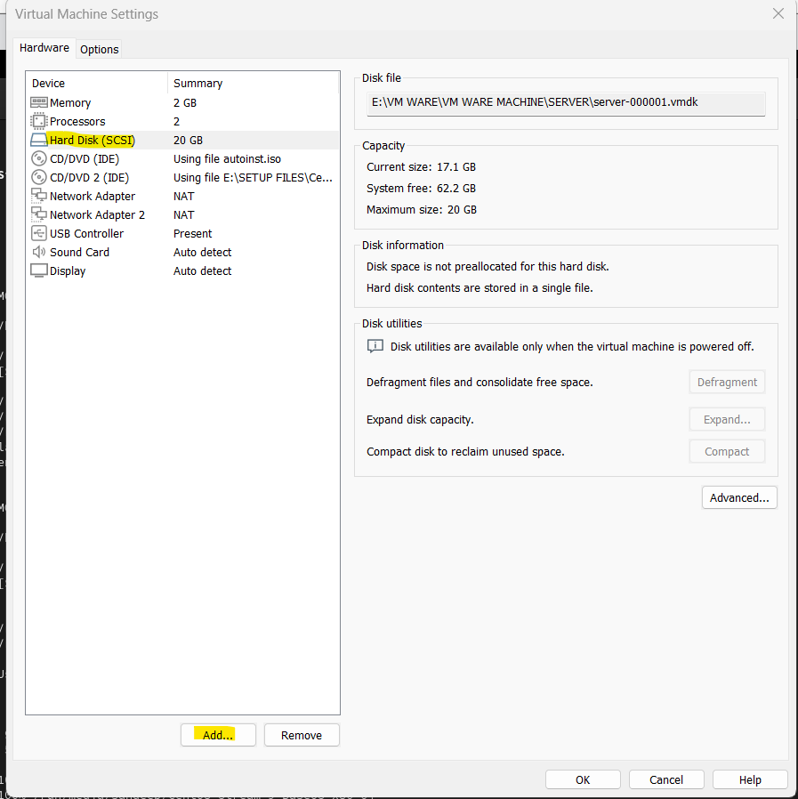

1.Click on the Hard disk portion and give the ADD after giving the ADD the page will popup

2.Then again select the Hard disk and give NEXT

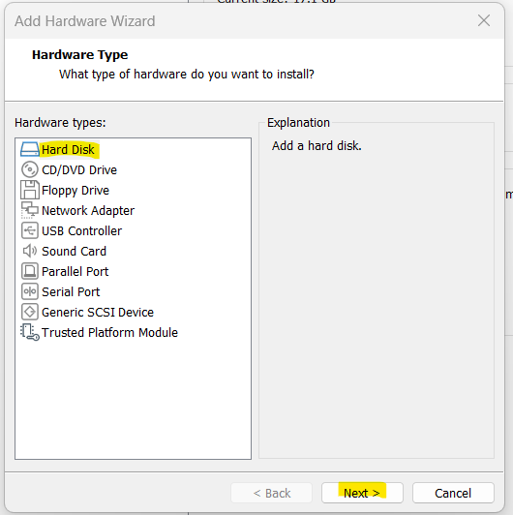

3.The page will get open select the SCSI and give NEXT

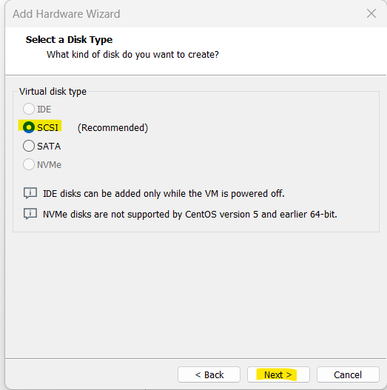

4.Select the first option Create A new virtual disk and give NEXT

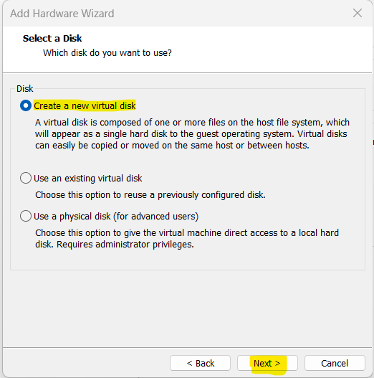

5.In the next page give the size for the new disk and select Store Virtual disk and give NEXT

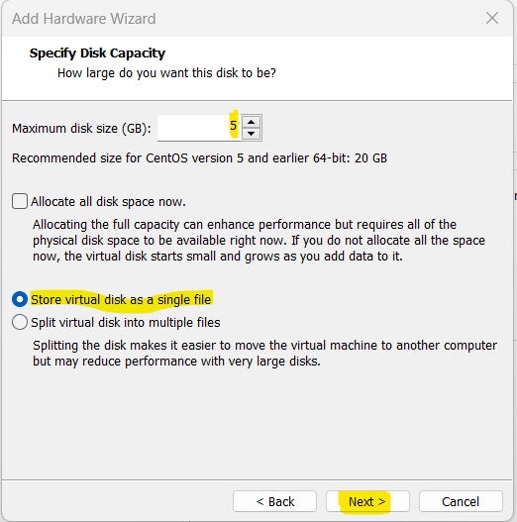

6.In the next page select the finish and press Ok in next page. Now the disk is added.

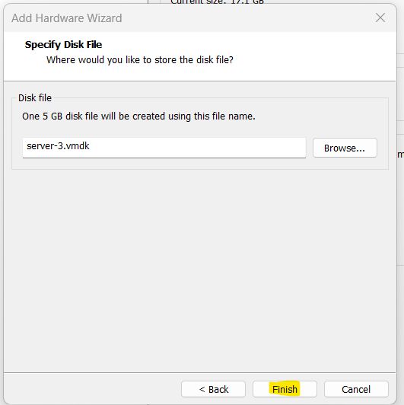

7.To check the disk is added or no (we need to reboot the VM machine)

8.After reboot the machine check with fdisk -l

Now the local disk is added

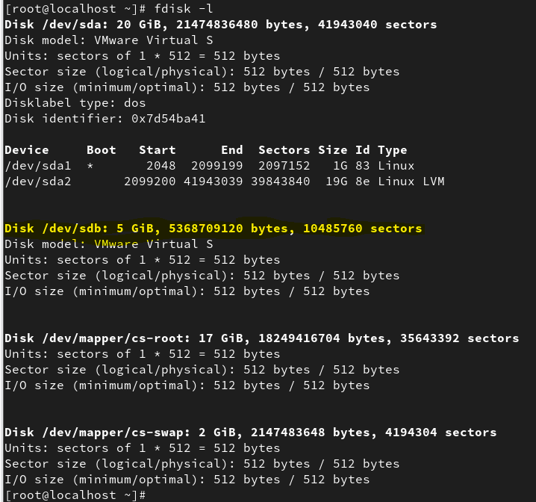

**9.** Need to create the partition on the disk.

fdisk /dev/sdb(it Is used to create the partion)

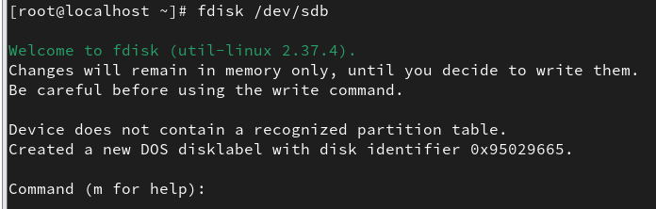

Select the p (it’s for the print)

Next select n (it’s for the new)

We need to select default p

1. Partition number just press ENTER
2. First sector just press ENTER
3. Last sector give the partition volume/size.
4. After giving the size check the partition is created successfully give the p (print option) to check the partition
5. At he last to save the changes give w. The partition will be saved

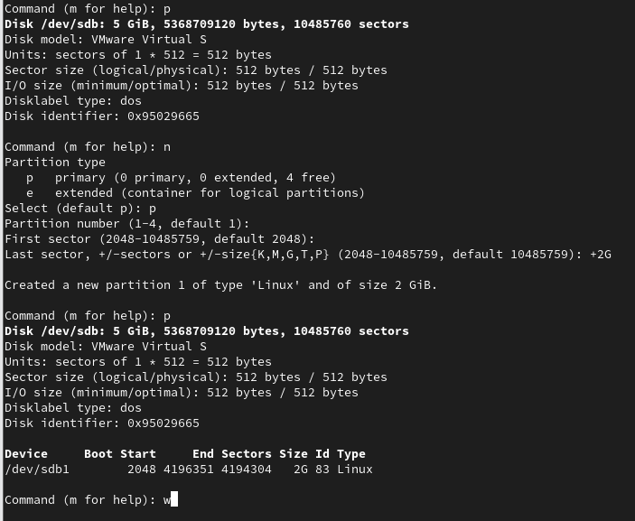

**10. Now create the file system**

Use the command (mkfs.xfs /dev/sdb1) to create the file

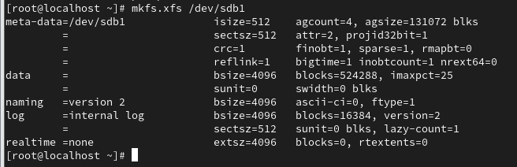

11.To check the status of the file system

Use the command (file -s /dev/sdb1)



12.Mount the file

. Create the (mkdir Disk1) use command (mount /dev/sdb1 /root/Disk1/) & check the status

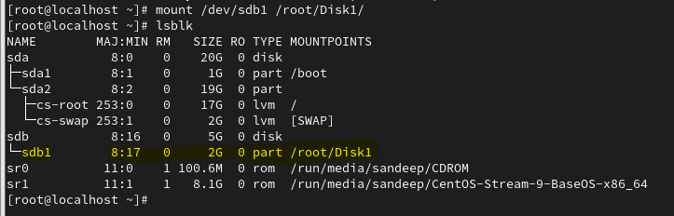

13. How to resize the disk.

1. Delete the partition without unmounting the disk

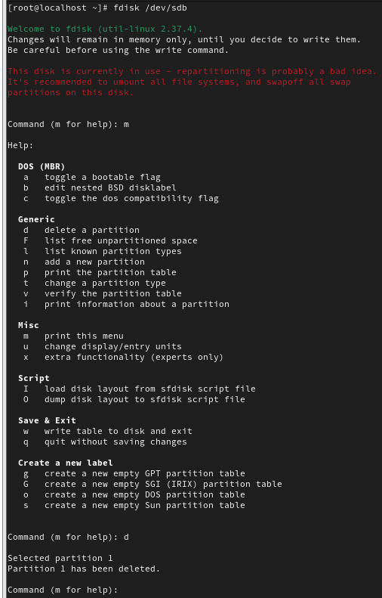

1. Add new partition

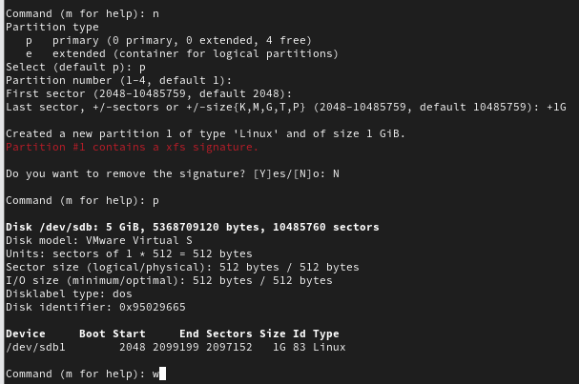

1. Command to resize the partition (xfs_growfs /dev/sdb1) and check the status

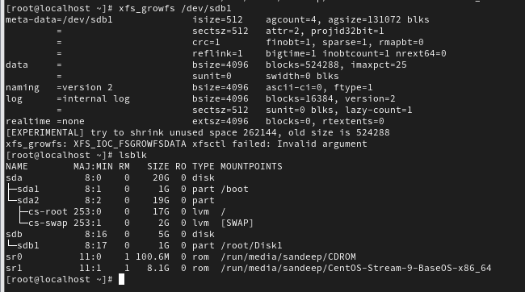

14. How to delete the disk

Use the command (echo '---'> /sys/class/block/sdb/device/delete)

This will delete the disk which is created.